**Overview of analysis**

The objective of this analysis is to see the tempretature stats in the months of June and December . we would obtain the data of tempreture is 2 seperate ask around. we the ask arounds are conducted , we would save the tempratures in a list and then turn them into a data frame, then we can obtain our needed data using the describe() method.

Result:

**June result:** Total count of 1700,mean of 74.9, min of 64.0 max of 85.0

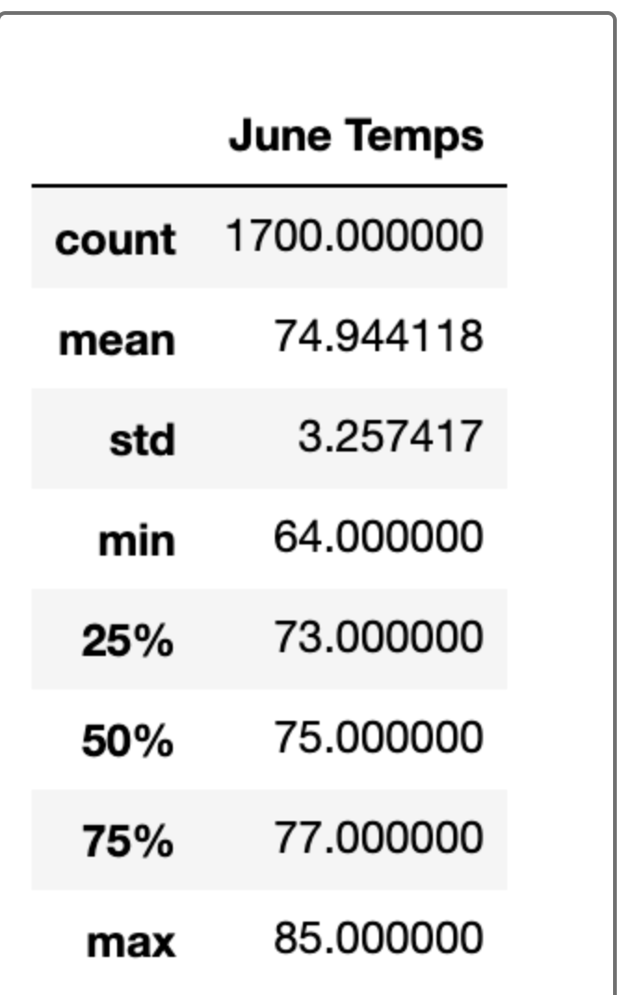

**December Results** : total count of 1517, mean of 71.0, min of 56.0, max of 83.0

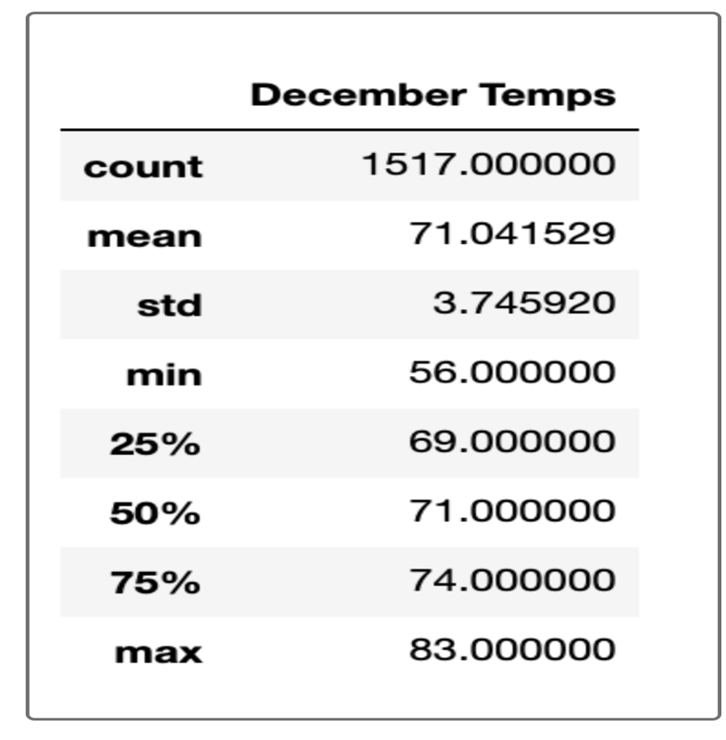

The standard deviation different between June and December is 0.5

# Summary

# Given the data, we can tell what the temperature is. But because there are other specifications for the weather such as rain, it shows we can conduct more ask arounds to see if people can actually go to the shops and if not we need to obtain more data, then we can determine how to build the shops and what areas are would make this area a prominent one for the building.